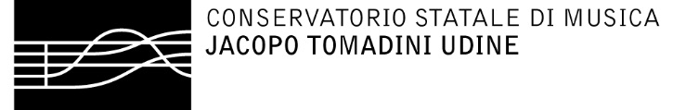

TO WHOM IT MAY CONCERN

Dear Madam/Sir,
with this letter I confirm the authenticity of the recording of my student Name ___________ Surname ___________.
The whole recording was played by her/him.

Yours sincerely,

Prof. Name and Surname

Signature

